Software Requirements Specification

For

Cinnamon Care MVC Web Application

**Prepared By : Rakitha Nonis (Internship)**

**Organization: Cinnamon Hotel Management IT**

**Date : 2/11/2020**

**Contents**

( 1 ) Introduction 3

1.1 Chapteroverview 3

1.2 Problem 3

1.3 Problem solution 4

1.4 Project aim 4

1.5 Scope 5

( 2 )Overall Description 5

2.1 Intended Audience and reading suggestions 5

2.2 Features 5

2.3 Operating environments 6

2.4 Product Perspective 6

2.5 User classes and Characteristics 7

2.6 Process model 7

( 3 ) Design 8

3. 1 Chapter overview 8

3.2 ER diagram 8

3.3 Flow chart diagram 8

3.4 User case diagram 8

# ( 1 ) Introduction

## Chapter overview

**The problem** – Due to the Covid-19 situation there is no way to get the health status of the visiting guests to cinnamon hotels.

**The solution** – Planned to develop a system get the details and decide that guest is good enough to enter to the hotel.

In this chapter mainly focuses to the introduction of problem which is being gone to solve by us and what the functionalities are used in our software. Firstly, we mentioned the problem introduction and boundary of the problem. Next respectively have mentioned attempted solutions of our problem, the definition of the problem and research questions related to the problem we are going to solve. The next part of this chapter we discuss about the solution that we present to identify the problem and project aim. These two topics will be explained in detail. Then we have mentioned the scope of our project and what are the objectives we identified. Next, we inserted the features of the prototype into this chapter. At the end of this chapter we have written the requirements which we need to make the software and those requirements would have divided into mainly four categories including hardware and software requirements, data requirements and technology stack.

## Problem

As we all know due to the Covid-19 situation of the country it’s good to maintain discipline otherwise its bit difficult to handle the situation. As we are in the tourism field lot of guests visit every day and it’s good to identify the visitors those who are good enough to enter to the hotel. We get some details of the guests those who are visiting to our hotels and predict that the relevant visitor can proceed or not. It is a good thing and because of that we can be notified if it is a safe place or not to the visitors as well as the staff. Some several diseases are found as an effect of this situation and mainly the temperature is checked for this, by using that temperature value we can predict the relevant person suffering from Covid-19.

## Problem solution

This application is design for the guests those who are visiting to Cinnamon hotels.

At the entrance the temperature is checked and if the temperature is in the valid range

visitor can enter to the hotel and visitor will be asked some related questions and some

Symptoms while filling the form. If the user is already exist in the system they can only

Give the temperature and the symptoms. The temp value will be asked at the lobby and

The restaurant entrances.

## Project aim

As human being and the busy schedule of our lives we cannot identify the patients and

Keep attention on other people is bit difficult. Because of that by using this system we can get a clear idea about a guest and get a full report of their behavior. Because of this

We can give the attention to the people who are visiting to the hotels and the staff who

Are working in the hotel and we can keep them touch about the current status of the

Hotel and the people.

## 1.5 Scope

This system can be used to detect the guests who are not suits to enter to the hotel due to situation of Covid-19. By using this the management can get a clear idea about the visitor by using some certain values and predictions. The guest should select some symptoms from the given list and the temperature of every guest is checked and it should be in a valid range to proceed. Using this a clear idea of a guest can be taken by referring the report of the system.

# ( 2 )Overall Description

## 2.1 Intended Audience and reading suggestions

All the staff members who are working at the lobby entrance and the restaurant entrances. This will be used for all the guest who visit to the Cinnamon hotels.

## 2.2 Features

* Create a new Asp.Net Web application using MVC architecture.
* Open Loads the application existing application on the project.
* Close project : Close currently opened applications.
* Properties : Display some main properties at the beginning such as title.
* Database : My SQL express 2019
* Process : Get some details , temperature , Symptoms and predict the person is infected or not.
* Exist : Application shut down.
* Workspace :
* Inserting the person to the system.
* Tools : Visual studio 2019 ,SQL express 2019 , Asp.Net Framework

## 2.3 Operating environments

• Windows 2000

• Windows XP

• Windows Vista

• Windows 7

• Windows 8

• Windows 10

• Mac OS X

• Linux

## 2.4 Product Perspective

This system is developed for Cinnamon hotels due to the covid-19 situation to make sure those who are visiting to the hotel are clear to enter.

It is good to everyone both visitors and the staff to maintain such a discipline like that and it will be a help to avoid others from the bad situation. This was developed mainly to run on windows but it can be access to mac OS and Linux as well.

## 2.5 User classes and Characteristics

All the staff members who are working at the lobby entrance and the restaurant entrances. This will be used for all the guest who visit to the Cinnamon hotels.

## 2.6 Process model

This is to show the path of the project and to introduce the selected process model, which was selected to develop. Iterative Model was selected accordingly, as it has become a main part of Software Development Life Cycle (SDLC). Use of Iterative Model, allows to make changes while the project is under construction and in the future as well. Which implies, once the planning is completed handful of phases are repeated as cyclically. This benefit is not applicable for other models such as Waterfall Model, since it is processed as step by step downwards. This exclusive advantage makes the iterative model, as the best selection among other SDLC models for this project.

# ( 3 ) Design

## 3. 1 Chapter overview

In this chapter covers the design decisions and diagrams involved in creating our software system. Entity relationship diagrams, activity diagrams and sequence diagrams are presented in this chapter. The discussions also document the several alternatives considered and rationale for deciding on the final designs.

## 3.2 ER diagram

––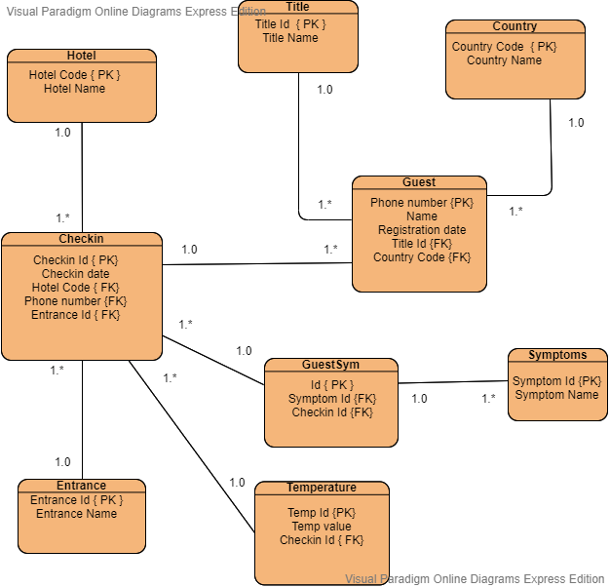

## 3.3 Flow chart diagram

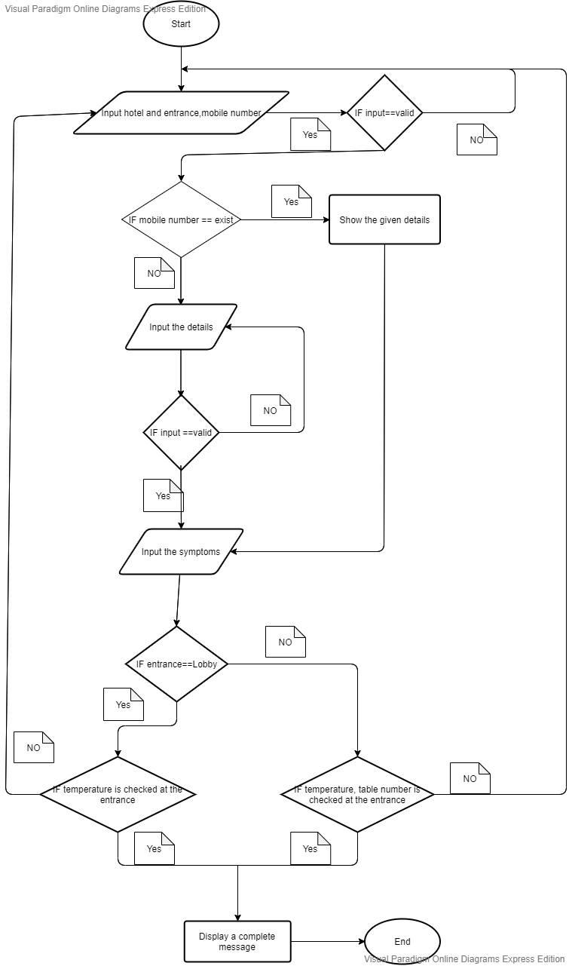

## 3.4 Use case diagram

